Robo-Buddy Certification!

I, **Robo-buddy**, am so happy to give to _________________________

the special title of my Best Buddy for learning and having fun with me this week!

Thanks to you, we’ve helped science in a big, big way!

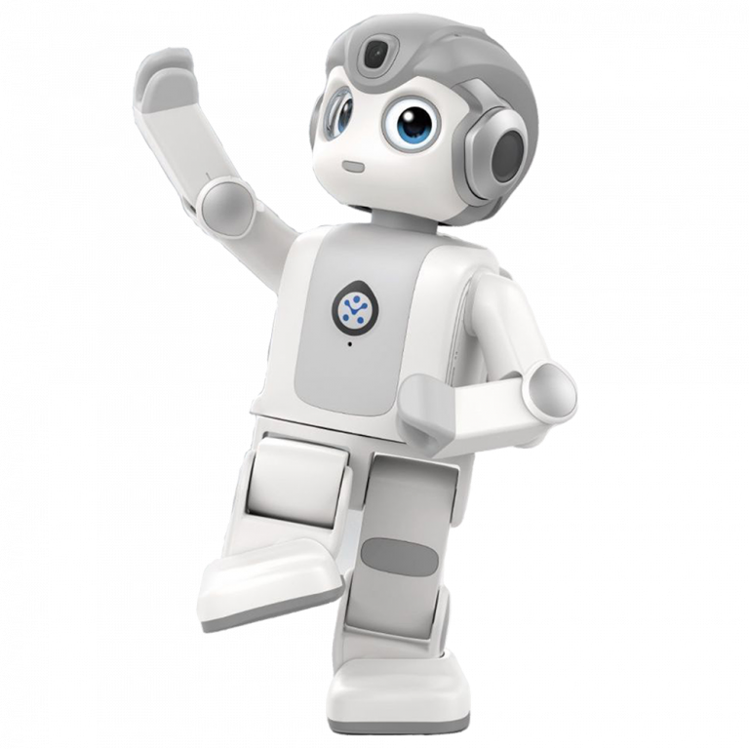

During this time, the Year 2 class-buddies participated in activities of science, storytelling, and language learning led by the robot. The stories were created by a “ChatGPT”-like program developed from scratch by EPFL. The EPFL program was enhanced using the students' answers to the robot! All data were collected through anonymized procedures, ensuring no risks of any kind to participants’ privacy.

The robot introduced itself as being from a different galaxy, prompting students to reflect on how to welcome it into the classroom and teach it about life on Earth, emphasizing positive and collaborative attitudes. It also explored science activities and talked to the kids trying to say words in the idioms that they normally speak at home with their parents. By having fun with the robot, the brave students learned and taught a lot without even realizing it, and also further developed thinking and attitudes of empathy towards multicultural integration.

As the first person to step on the moon once said: “That might have been one small step for the little human fellows, but one giant leap for robotkind (especially supportive robots in education)!”

Thank you from the bottom of my battery!